Advanced Database Training
2026
Vaishnavi Kamthe

Assignment 6b

Question
Following image shows the Snowflake Schema model. Based on that please do the following,
- Create the tables in mysql database as per the schema
- Add appropriate columns in every table, give primary key, foreign keys whenever applicable
- Insert rows in each table
- Write a query to find amount_sold and quantity sold for each country by category for each year
- Create the ER diagram of all the schema tables and save it as a image file (you can use mysql workbench or DBaever to generate the ER diagram)
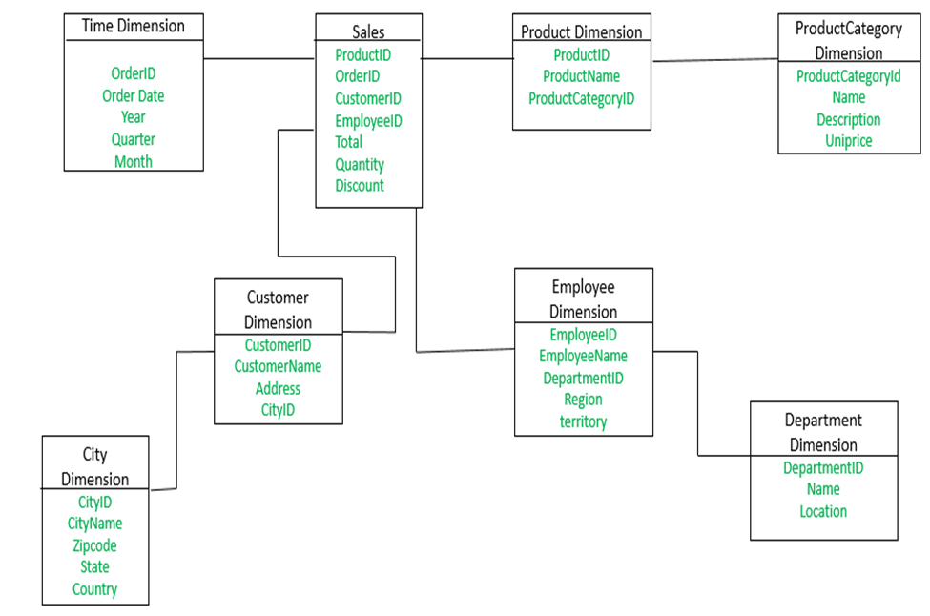
CREATE DATABASE snowflake;
USE snowflake;
CREATE TABLE time_dim (
order_id INT PRIMARY KEY,
order_date DATE,
year INT,
quarter INT,
month INT
);
CREATE TABLE product_category_dim (
product_category_id INT PRIMARY KEY,
name VARCHAR(100),
description VARCHAR(200),
unit_price DECIMAL(10,2)
);
CREATE TABLE product_dim (
product_id INT PRIMARY KEY,
product_name VARCHAR(100),
product_category_id INT,
FOREIGN KEY (product_category_id) REFERENCES product_category_dim(product_category_id)
);
CREATE TABLE city_dim (
city_id INT PRIMARY KEY,
city_name VARCHAR(100),
zipcode VARCHAR(20),
state VARCHAR(100),
country VARCHAR(100)
);
CREATE TABLE customer_dim (
customer_id INT PRIMARY KEY,
customer_name VARCHAR(100),
address VARCHAR(200),
city_id INT,
FOREIGN KEY (city_id) REFERENCES city_dim(city_id)
);
CREATE TABLE department_dim (
department_id INT PRIMARY KEY,
name VARCHAR(100),
location VARCHAR(100)
);
CREATE TABLE employee_dim (
employee_id INT PRIMARY KEY,
employee_name VARCHAR(100),
department_id INT,
region VARCHAR(100),
territory VARCHAR(100),
FOREIGN KEY (department_id) REFERENCES department_dim(department_id)
);
CREATE TABLE sales (
product_id INT,
order_id INT,
customer_id INT,
employee_id INT,
total DECIMAL(10,2),
quantity INT,
discount DECIMAL(5,2),
FOREIGN KEY (product_id) REFERENCES product_dim(product_id),
FOREIGN KEY (order_id) REFERENCES time_dim(order_id),
FOREIGN KEY (customer_id) REFERENCES customer_dim(customer_id),
FOREIGN KEY (employee_id) REFERENCES employee_dim(employee_id)
);
INSERT INTO time_dim VALUES
(1, '2024-01-10', 2024, 1, 1),
(2, '2024-02-15', 2024, 1, 2);
INSERT INTO product_category_dim VALUES
(1, 'Electronics', 'Electronic Items', 50000),
(2, 'Mobile', 'Mobile Devices', 20000);
INSERT INTO product_dim VALUES
(101, 'Laptop', 1),
(102, 'Phone', 2);
INSERT INTO city_dim VALUES
(1, 'Pune', '411001', 'Maharashtra', 'India'),
(2, 'Mumbai', '400001', 'Maharashtra', 'India');
INSERT INTO customer_dim VALUES
(1, 'Alice', 'Street 1', 1),
(2, 'Bob', 'Street 2', 2);
INSERT INTO department_dim VALUES
(1, 'Sales', 'HQ'),
(2, 'Marketing', 'Branch');
INSERT INTO employee_dim VALUES
(1, 'John', 1, 'West', 'A'),
(2, 'Sara', 2, 'North', 'B');
INSERT INTO sales VALUES
(101, 1, 1, 1, 50000, 1, 0),
(102, 2, 2, 2, 40000, 2, 5);
SELECT
c.country,
pc.name AS category,
t.year,
SUM(s.total) AS amount_sold,
SUM(s.quantity) AS quantity_sold
FROM sales s
JOIN product_dim p ON s.product_id = p.product_id
JOIN product_category_dim pc ON p.product_category_id = pc.product_category_id
JOIN customer_dim cust ON s.customer_id = cust.customer_id
JOIN city_dim c ON cust.city_id = c.city_id
JOIN time_dim t ON s.order_id = t.order_id
GROUP BY c.country, pc.name, t.year;
